Basics Of Computer

2024

Muhammad Hamza Sabir

AG

10/1/2024

### What You Will Learn From Here

Definition. Components. Function. How many types of Computer? Basic Operations. How to turn on Computer? How to turn off Computer? How to shutdown computer Properly? How to install updates? Data and Information. Common Software. How many of types Operating System? Networking. Security. Usage.

### Definition

A Computer is an electronic device that process data and performs tasks according to set of instruction is called a program.

### Components

**Hardware:**

The Physical Parts Of a Computer is called hardware like (CPU, Memory, Storage Devices, input/output devices) 

Fig 1.1

### Software:

The Programs and operating System that run on the hardware. Like Games MS Office, Etc. Fig 1.2

Fig 1.2

## Functions:

* **Input:** Receiving data(e.g.,. Keyboard, Mouse ).
* **Processing:**  Performing operations on the data (e.g., CPU).
* **Storage:** Saving Data(e.g. hard drive, SSD)
* **Output:** Displaying Result (e.g. Monitor, Printer)

**Types of computer:**

* **Desktop:** Stationary Computers used at desk.
* **Laptop:** Portable Computers.
* **Tablet:** Handheld Computers with touch screen.
* **Server:** Computers that provide data to other computers on a network.
* **Smart phone:** Mobile phones with advanced Computing **capabilities**.
* **Main Frames:** Powerful computer used by large organizations for bulk data processing.
* **Super Computer:** Extremely
* **Wearable Computers:**

## Basic Operations:

* **Bootxing:** Starting up the Computer.
* **Shutting down:** Turning off the computer.
* **Installing software:** Adding a new program.
* **Updating Software:** To make in software that was pre-installed.
* **Input:** Entering data.
* **Processing:** Manipulating Data.
* **Storage:** Saving data.
* **Output:** Displaying Result.
* **Control:** Managing the operations

**Turn On Computer:**

1. Connect the power supply.
2. Press the power button on the computer case.
3. Wait for operating System.

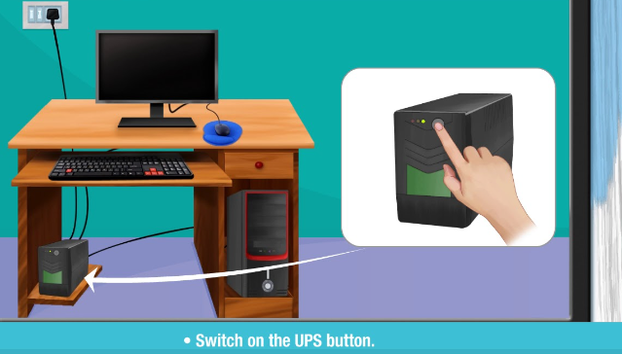Fig 1.3

#### Turn off computer

1. Click the Start button.
2. Select the Power icon.
3. Chose Shutdown.

Fig 1.4

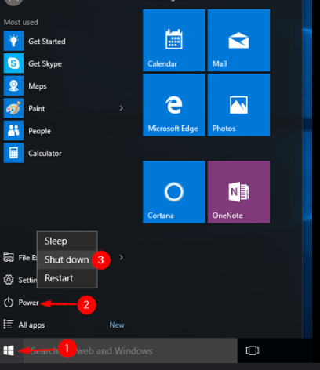Fig 1.4

**To Shut Down Computer Properly:**

1. Press **Windows + R.**
2. Then type **Control Panel.**
3. Go on **Power Options.**
4. If you can’t find **Power Options** then type this >**Control Panel\All Control Panel Items\Power Options**

xx on the search bar.

1. Then select **chose what the power button do.**

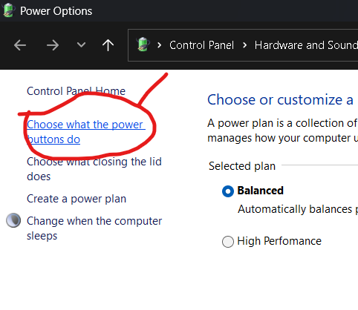Fig 1.5

1. Then select **change Settings that are currently unavailable.**
2. Then un-tick **turn up fast start up.**

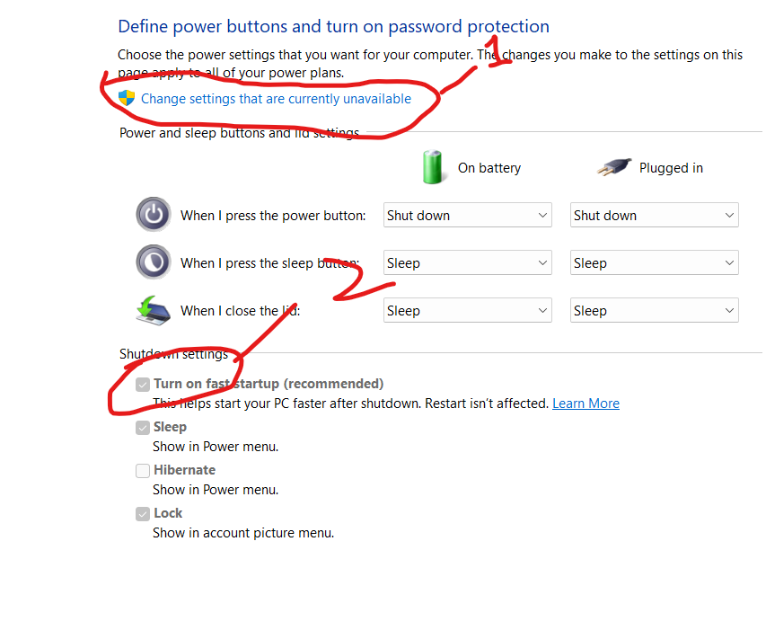Fig 1. 6

##### Installing updates

Windows updates may be classified into several kinds, every serving a selected reason. Here are the major kinds of updates and the steps to put in them:

Major Types of Windows Updates

Feature Updates

Purpose: Introduce new capabilities and enhancements to the running device.

Frequency: Typically released yearly.

Steps to Install:

Go to Start > Settings > Windows Update.

Click Check for updates.

If a characteristic update is available, click Download and set up.

Quality Updates

Purpose: Provide protection patches, trojan horse fixes, and overall performance improvements.

Frequency: Released monthly, frequently called “Patch Tuesday”.

Steps to Install:

Go to Start > Settings > Windows Update.

Click Check for updates.

If updates are to be had, click on Install now.

Security Updates

Purpose: Address protection vulnerabilities to shield your gadget from threats.

Frequency: Released as wanted, regularly covered in monthly nice updates.

Steps to Install:

Go to Start > Settings > Windows Update.

Click Check for updates.

If protection updates are available, click on Install now.

Driver Updates

Purpose: Update drivers for hardware additives to ensure compatibility and overall performance.

Frequency: Released as wanted.

Steps to Install:

Go to Start > Settings > Windows Update.

Click Check for updates.

If driver updates are to be had, click on Install now.

Definition Updates

Purpose: Update the definition database for Windows Defender to protect against malware.

Frequency: Released regularly, every now and then a couple of instances an afternoon.

Steps to Install:

Go to Start > Settings > Windows Update.

Click Check for updates.

If definition updates are available, click Install now.

Servicing Stack Updates (SSU)

Purpose: Ensure the reliability of the update system itself.

Frequency: Released as needed.

Steps to Install:

Go to Start > Set

Windows Update:

Steps to Check for and Install Windows Updates

Open Settings:

Click on the Start menu (Windows icon) at the bottom-left corner of your screen.

Select Settings (gear icon).

Navigate to Windows Update:

In the Settings window, click on Update & Security.

Select Windows Update from the menu on the left.

Check for Updates:

Click the Check for updates button. Windows will start searching for available updates.

Download and Install Updates:

If updates are found, they will be listed. Click Download to start downloading the updates.

Once the download is complete, click Install now to install the updates.

Restart Your Computer:

Some updates may require a restart to complete the installation. If prompted, click Restart now or schedule the restart for a later time.

Additional Tips

Automatic Updates: Ensure that automatic updates are enabled so that your system stays up-to-date without manual intervention. You can check this in the Advanced options under Windows Update settings.

Active Hours: Set your active hours to prevent updates from interrupting your work. This can be done in the Change active hours section under Windows Update settings.

**Data and Information:**

Data

Data refers to raw, unprocessed facts and figures without any context. These can be numbers, characters, symbols, or any other output that can be processed by a computer. Data on its own doesn’t have meaning until it is interpreted or processed to become useful.

Examples:

A list of temperatures recorded over a week.

Survey responses from a group of people.

Information

Information is data that has been processed, organized, or structured in a way that adds context and meaning. It is useful for decision-making and understanding. Information is essentially data that has been interpreted.

Examples:

The average temperature for the week calculated from the recorded temperatures.

A report summarizing the survey responses to identify trends or patterns.

Key Differences

Nature: Data is raw and unprocessed; information is processed and meaningful.

Purpose: Data is used as input for processing; information is the output of this processing.

Context: Data lacks context; information provides context.

**Common Software:**

Here are some not unusual and crucial software program programs for Windows that many users find useful:

1. Web Browsers

Google Chrome: Fast and widely used with huge extension help.

Mozilla Firefox: Known for its privateness features and customization alternatives.

Microsoft Edge: Built-in browser with true overall performance and integration with Windows.



2. Office Suites

Microsoft Office: Includes Word, Excel, PowerPoint, and greater.

LibreOffice: A free and open-supply alternative to Microsoft Office.

3. Security Software

Windows Defender: Built-in antivirus and anti-malware safety.

TotalAV Antivirus: Comprehensive security suite with extra functions like VPN1.

4. Cloud Storage

OneDrive: Integrated with Windows for easy report syncing and storage.

Google Drive: Offers 15GB of loose storage and integrates nicely with Google’s productivity tools2.

Five. Media Players

VLC Media Player: Supports a extensive variety of audio and video formats.

Spotify: Popular song streaming service with a extensive library2.

6. Productivity Tools

Notepad : Advanced text editor for coding and trendy textual content enhancing.

Evernote: Note-taking app that enables prepare your thoughts and tasks.

7. File Compression

7-Zip: Free and open-supply report archiver with high compression ratio.

WinRAR: Popular tool for compressing and extracting files.

8. Communication

Microsoft Teams: Collaboration tool for paintings and faculty.

Zoom: Widely used for video conferencing and on-line meetings.

9. Graphics and Design

GIMP: Free and open-supply photo editor.

Adobe Photoshop: Industry-wellknown for image editing and picture layout.

10. Utilities

CCleaner: Helps smooth up needless documents and optimize gadget performance.

Malwarebytes: Additional layer of protection against malware and different threats.

**How many types of operating system**

Operating systems can be classified into numerous kinds primarily based on their functionality and use instances. Here are the major kinds:

1. Batch Operating System

Description: Executes batches of jobs with out person interplay.

Example: Early mainframe structures.

2. Time-Sharing Operating System

Description: Allows multiple users to percentage device resources concurrently.

Example: UNIX.

Three. Distributed Operating System

Description: Manages a group of independent computers and makes them seem as a unmarried computer.

Example: Amoeba, Plan 9.

Four. Network Operating System

Description: Provides offerings to computers linked to a community.

Example: Windows Server, Linux.

Five. Real-Time Operating System (RTOS)

Description: Processes statistics as it is available in, usually utilized in embedded systems.

Example: VxWorks, RTLinux.

6. Multi-User Operating System

Description: Allows a couple of customers to get right of entry to the pc concurrently.

Example: UNIX, Linux.

7. Single-User Operating System

Description: Designed for one consumer at a time.

Example: Windows 10, macOS.

Eight. Mobile Operating System

Description: Designed particularly for cell devices.

Example: Android, iOS.

Nine. Embedded Operating System

Description: Designed to operate on embedded systems.

Example: Embedded Linux, Windows Embedded.

10. Hobbyist Operating System

Description: Created by using fans for getting to know and experimentation.

Example: MenuetOS, KolibriOS.

###### How many operating system

There are severa running systems available, every designed for exclusive varieties of gadgets and use instances. Here are a number of the most well-known ones:

Popular Operating Systems

Microsoft Windows

Versions: Windows 10, Windows eleven, Windows Server.

MacOS

Versions: macOS Ventura, macOS Monterey.

Linux Distributions

Examples: Ubuntu, Fedora, Debian, CentOS, Red Hat Enterprise Linux (RHEL).

UNIX

Examples: Solaris, AIX, HP-UX.

Chrome OS

Designed for: Chromebooks.

Android

Designed for: Smartphones, pills.

IOS

Designed for: iPhones, iPads.

Windows Phone

Designed for: Windows-based smartphones (discontinued).

FreeBSD

Designed for: Servers, desktops.

Tizen

Designed for: Smart TVs, wearables, cellular gadgets.

Specialized Operating Systems

Real-Time Operating Systems (RTOS)

Examples: VxWorks, FreeRTOS.

Embedded Operating Systems

Examples: Embedded Linux, Windows Embedded.

Network Operating Systems

Examples: Cisco IOS, Juniper Junos.

Hobbyist and Experimental Operating Systems

ReactOS

Designed to be: Compatible with Windows programs.

Haiku

Inspired with the aid of: BeOS.

##### Networking

Networking

Networking can be defined in two primary contexts:

Social and Professional Networking:

Definition: The action or process of interacting with others to exchange information and develop professional or social contacts.

Purpose: Used by professionals to expand their circles of acquaintances, find job opportunities, and stay updated on industry trends12.

Examples: Attending industry conferences, joining professional organizations, or using platforms like LinkedIn.

Computer Networking:

Definition: The linking of computers to allow them to operate interactively.

Purpose: Enables the sharing of resources and information between computers, enhancing communication and collaboration32.

Examples: Local Area Networks (LAN), Wide Area Networks (WAN), and the Internet.

Networking, whether social or technical, plays a crucial role in connecting people and systems, facilitating communication, and sharing resources.

**Security**

Security

Security can be defined in several contexts, each with its own specific meaning:

General Definition:

Security refers to the state of being free from danger or threat. It encompasses measures taken to protect against crime, attack, or other harm1.

Information Security:

Definition: Protecting information from unauthorized access, disclosure, alteration, and destruction.

Examples: Encryption, firewalls, and secure passwords.

Physical Security:

Definition: Measures designed to protect physical assets and people from harm.

Examples: Security guards, surveillance cameras, and access control systems.

Financial Security:

Definition: The assurance of financial stability and the ability to meet financial obligations.

Examples: Savings, investments, and insurance.

National Security:

Definition: The protection of a nation from external and internal threats.

Examples: Military defense, intelligence services, and counter-terrorism measures.

Job Security:

Definition: The assurance that an individual will retain their job without the risk of becoming unemployed.

Examples: Long-term contracts, strong company performance, and union protections.

Synonyms

Protection

Safety

Defense

Safeguarding

Antonyms

Vulnerability

Danger

Risk

Usage

Usage refers to the way in which something is used or the fact of being used. It can be understood in different contexts:

General Definition:

Definition: The action of using something or the fact of being used.

Example: “The usage of water in the household has increased.”

Linguistic Usage:

Definition: The way in which a word or phrase is normally and correctly used in a language.

Example: “The correct usage of the word ‘affect’ versus ‘effect’.”

Customary Practice:

Definition: Habitual or customary practice, especially as creating a right, obligation, or standard.

Example: “The usage of certain rituals in cultural ceremonies.”

Synonyms

Utilization

Use

Employment

Consumption

Operation

Examples

“A survey of internet usage among teenagers.”

“The usage of this equipment requires proper training.”